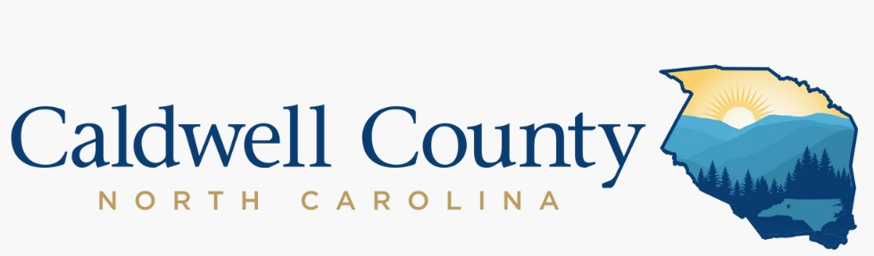

For Immediate Release | Contact: | Paige Counts
May 10, 2024 |  | Public Information Officer
 |  | 828-757-7879
 |  | pcounts@caldwellcountync.org

Caldwell Economic Development Celebrates Local Industry
Caldwell County Economic Development proudly celebrates local industries that significantly contribute to the economic prosperity and vitality of our community during Economic Development Week. With a steadfast focus on acknowledging achievements, fostering collaboration, and strategizing for future growth, Economic Development Week underscores the paramount importance of inclusive and sustainable economic initiatives.
Caldwell County continues to distinguish itself as a hub for thriving businesses and a desirable community for residents. According to data sourced from the Economic Policy Institute's Family Budget Map and the Average Private Sector Wage from NC Department of Commerce, the county ranks as the eighth most affordable county in North Carolina for families with children and the eleventh for those without.
"Economic Development Week serves as a pivotal moment for us to reflect on our collective achievements and to chart a course for a future defined by inclusive and sustainable growth," remarked Ashley Bolick, Director of Caldwell County Economic Development. "Our Economic Development Advisory Committee has meticulously crafted a strategic plan aimed at both attracting industry to the county and growing existing industry, and we are delighted to have recognized local businesses and individuals who have played instrumental roles in advancing the economic landscape of our county at our local Industry Appreciation Lunch."
During the luncheon, the Caldwell County Economic Development bestowed awards and accolades upon industry leaders for their significant milestones and contributions.
Caldwell Community College and Technical Institute was named “Partner of the Year.” CCC&TI has emerged as a state and national model for seamless education, thanks to collaborative efforts with public school systems and local governments in Caldwell and Watauga counties.
FleetGenius, one of the nation's fastest-growing manufacturers and solutions providers for commercial trash compactors and containers, was recognized as “Industry of the Year.” Employing more than 250 workers, FleetGenius has become a cornerstone of Caldwell County's industrial landscape.
Scott Hildebran, City Manager of Lenoir, was bestowed with the distinguished Herman Anderson Award. This accolade recognizes an individual who demonstrates outstanding engagement in the realm of economic development and exhibits genuine efforts to bolster Caldwell County's economy. Since assuming the role of city manager in 2015, Hildebran has spearheaded numerous projects that have not only augmented Lenoir's economic base but have also enhanced the overall quality of life for its residents.

Lenoir Mirror, founded in 1913, was honored with the esteemed “Legacy Award.” Throughout its century-long existence, Lenoir Mirror has maintained its status as a premier supplier of mirror and glass products to various industries nationwide. The company's enduring commitment to excellence, innovation, and resilience exemplifies its remarkable legacy.
<MORE>

Caldwell Economic Development also recognized the invaluable partnerships forged with businesses between 2021 and 2023. Those businesses include Adhezion Biomedical, Exela Pharma Sciences, FleetGenius, Harmony Timberworks, MDI, and Servpro of Alexander, Caldwell, Burke and Catawba Counties. Industries who commemorated milestone anniversaries in 2023 are Blue Ridge Sanitation (20 years), Marx Industries, Inc, (40 years), D.R. Kincaid Chair (40 years), Caldwell Woodcarvings (50 years), Grand Manor Furniture (60 years), Neptco (70 years), Hammary Furniture (80 years), Caldwell Glass (80 years), and Lenoir Mirror (110 years).
###
Photo Captions:
Photo 1: CCC&TI President Dr. Mark Poarch, staff, and board members receive the Partner of the Year Award at the Industry Appreciation Luncheon.
Photo 2: Fleet Genius President & CEO Andreas Gruson and staff accept the Industry of the Year Award.
Photo 3: Lenoir City Manager Scott Hildebran receives the Herman Anderson Award.
Photo 4: Representatives from Lenoir Mirror accept the Legacy Award.

